Travel Memory Application Deployment

┌────────────────────┐
│ End User │
│ (Browser / Mobile) │
└─────────┬──────────┘
│
HTTP / HTTPS
│
┌──────────────────▼──────────────────┐
│ Application Load Balancer (ALB) │
│ (Optional – for scalability & SSL) │
└──────────────────┬──────────────────┘
│
┌──────────▼──────────┐
│ EC2 Instance │
│ │
│ ┌───────────────┐ │
│ │ Nginx │ │
│ │ (Reverse Proxy │ │
│ │ & Static UI) │ │
│ └───────┬───────┘ │
│ │ │
│ ┌───────▼────────┐ │
│ │ Node.js Backend │ │
│ │ (PM2 Managed) │ │
│ └────────────────┘ │
│ │
└──────────────────────┘
Create EC2 instance and installed nginx:
Login to ec2 instance using putty:
Enter: public dns in the credentials section and next screen enter ec2-user
sudo apt update
sudo dnf install -y nginx git firewalld

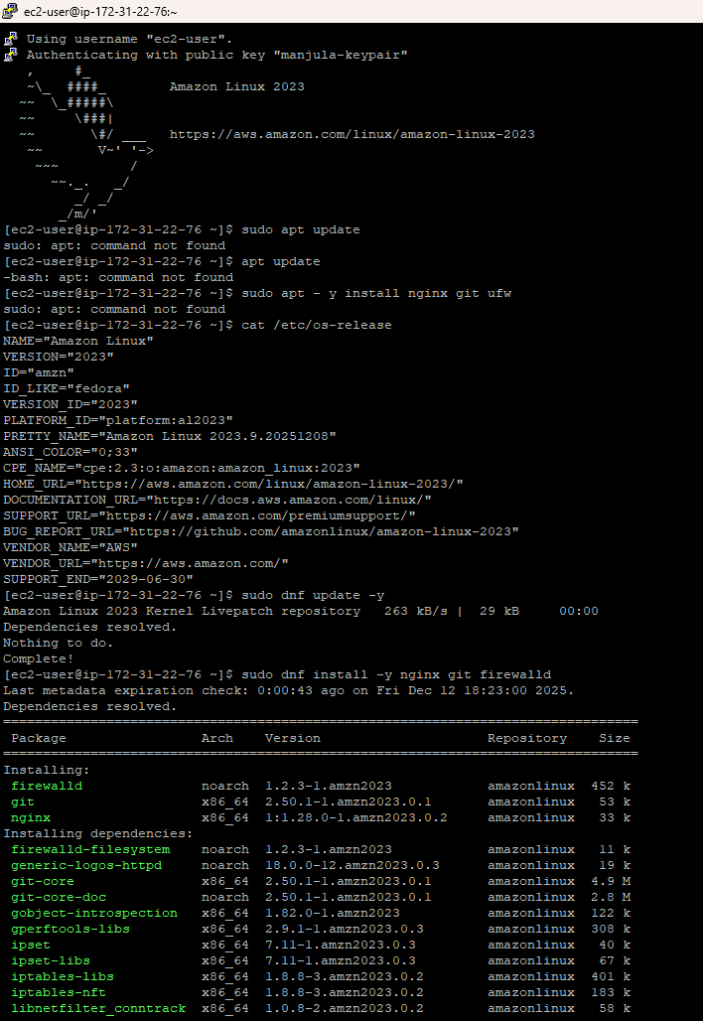
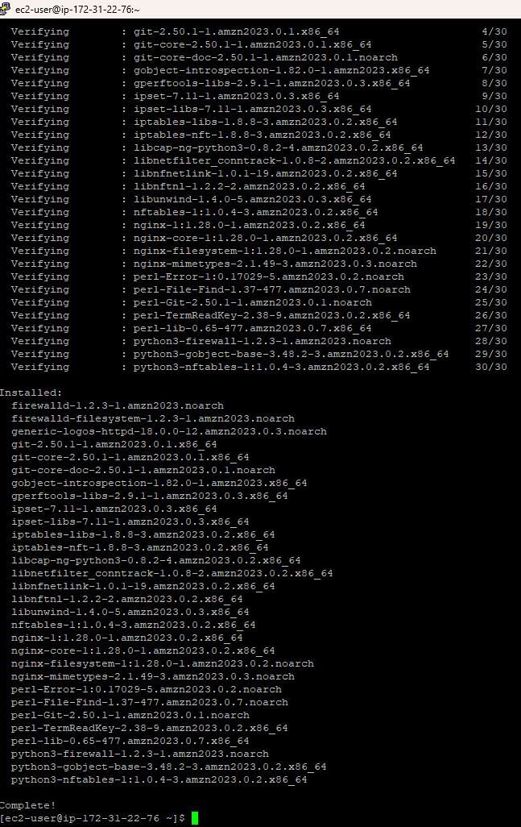
sudo systemctl enable --now nginx

Go to default nginx directory:
cd /usr/share/nginx/html

Enter the following to Replace the default index.html:
sudo tee index.html <<EOF
<!DOCTYPE html>
<html>
<head>
<title>Welcome to My EC2 Website</title>
<style>
body { font-family: Arial; text-align: center; margin-top: 50px; }
h1 { color: #2E8B57; }
</style>
</head>
<body>
<h1>Hello from Amazon Linux EC2!</h1>
<p>This is a sample Nginx page deployed on AWS.</p>
</body>
</html>

Open Port 80
Sudo firewall-cmd --add-service=http --permanent
Sudo firewall-cmd –reload

Test :
http://<your-public-ip>
http://ec2-98-93-49-85.compute-1.amazonaws.com/
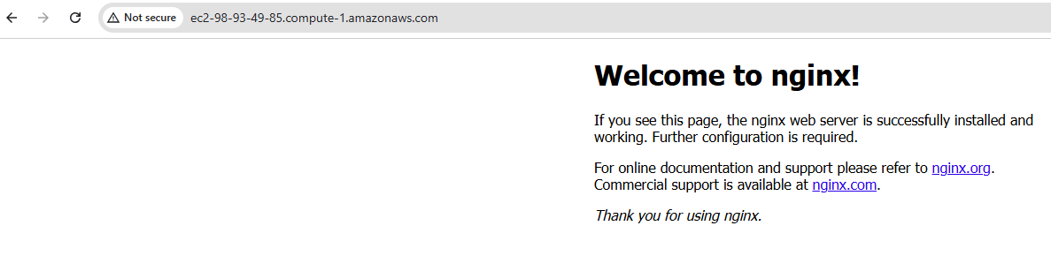
git clone https://github.com/UnpredictablePrashant/TravelMemory
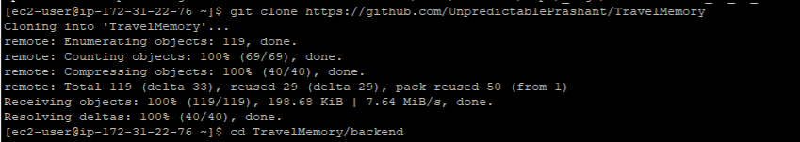

# 1. Update system
sudo dnf update -y

# 2. Install Node.js 18 and npm from NodeSource
curl -fsSL https://rpm.nodesource.com/setup_18.x | sudo bash -
sudo dnf install -y nodejs

# 3. Install PM2 globally
sudo npm install -g pm2

# 4. Navigate to your app folder and install dependencies
cd /path/to/your/cloned/repo
npm install
pm2 :
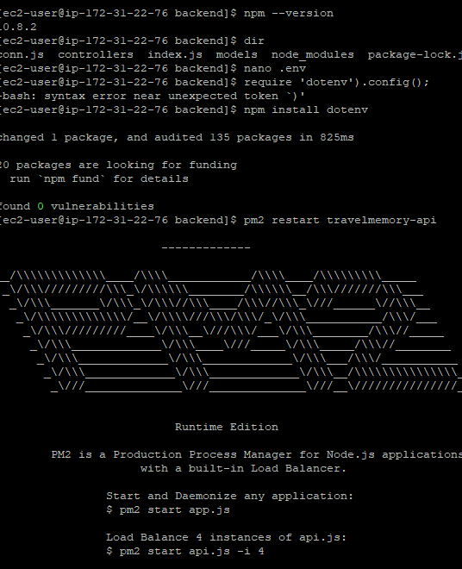

sudo apt update

sudo apt install nodejs npm -y

sudo apt install nginx -y

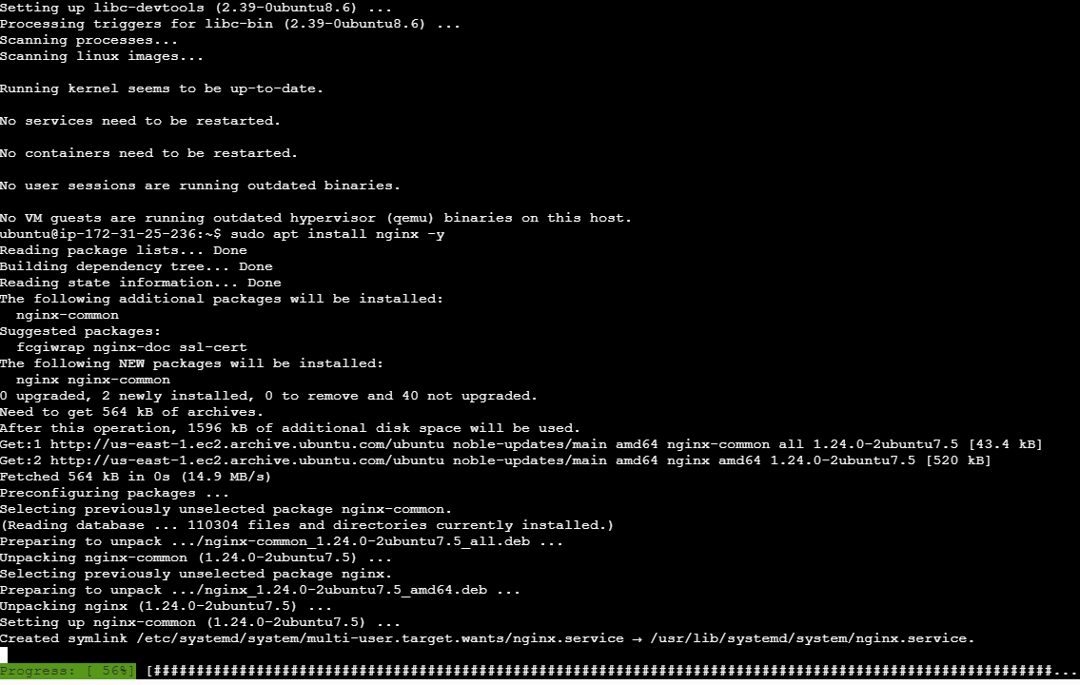

sudo apt install git -y
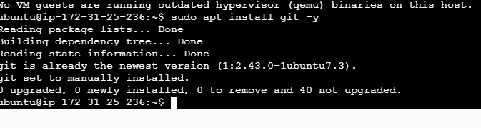
# Verify installations
node --version
npm --version
nginx -v

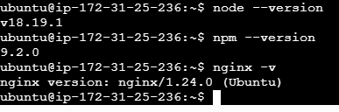

Clone Git repository : git clone https://github.com/UnpredictablePrashant/TravelMemory
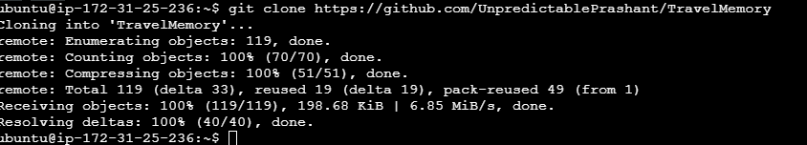
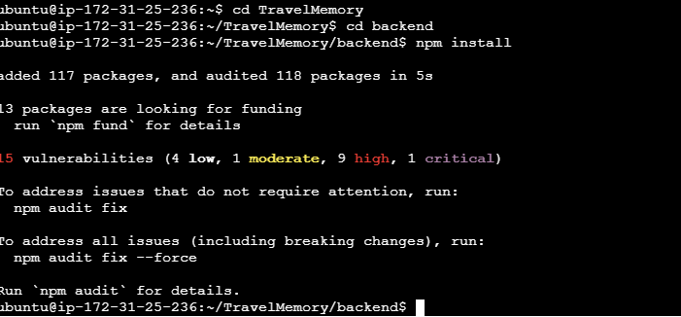
sudo nano .env
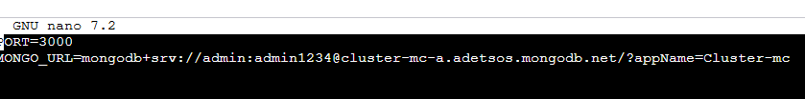

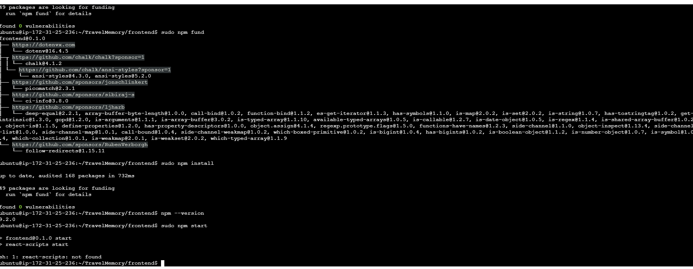
Sudo npm run build
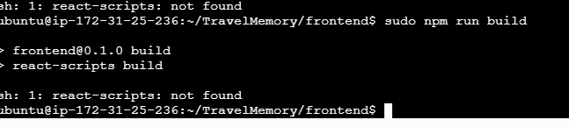
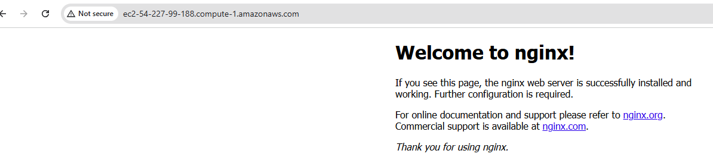

sudo nano /etc/nginx/sites-available/travel-memory
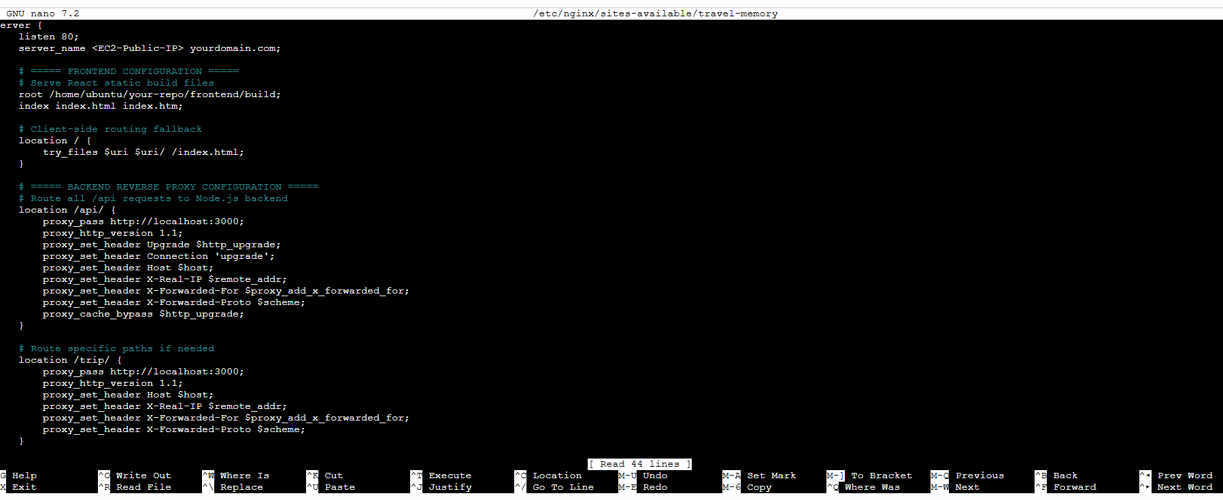
sudo ln -s /etc/nginx/sites-available/travel-memory /etc/nginx/sites-enabled/
sudo nginx -t
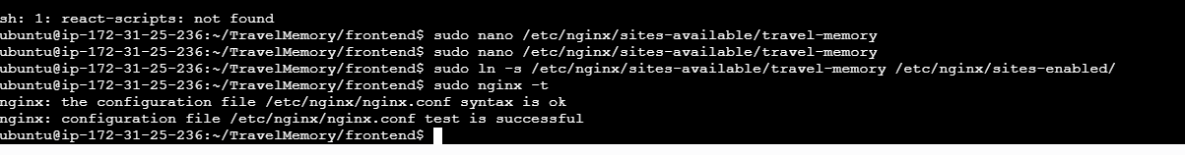
# Restart Nginx
sudo systemctl restart nginx

# Enable Nginx to start on boot
sudo systemctl enable nginx

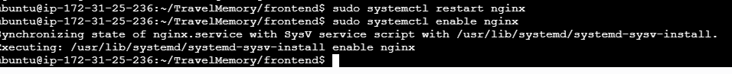
sudo npm install -g pm2
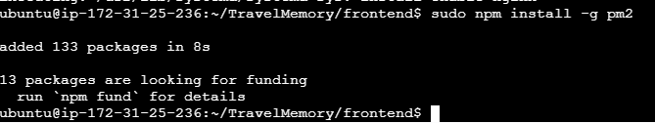

pm2 start index.js --name "travel-memory-backend"

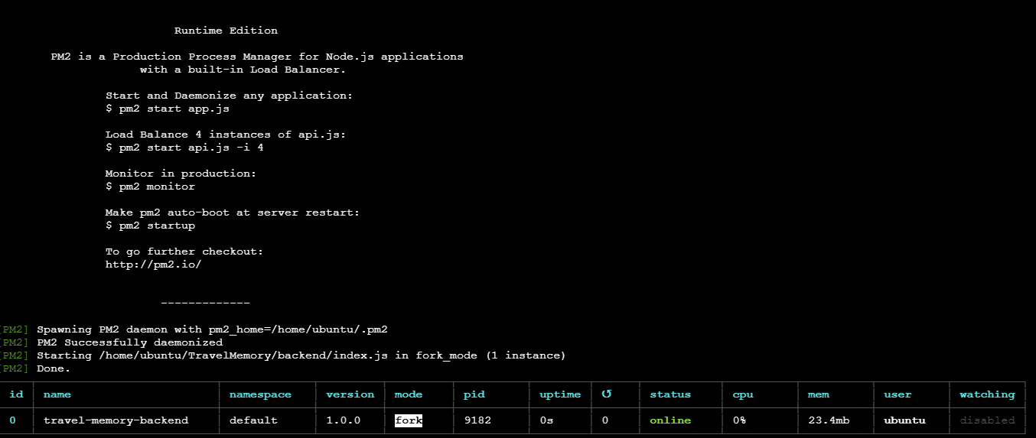

pm2 save
pm2 restart travel-memory-backend

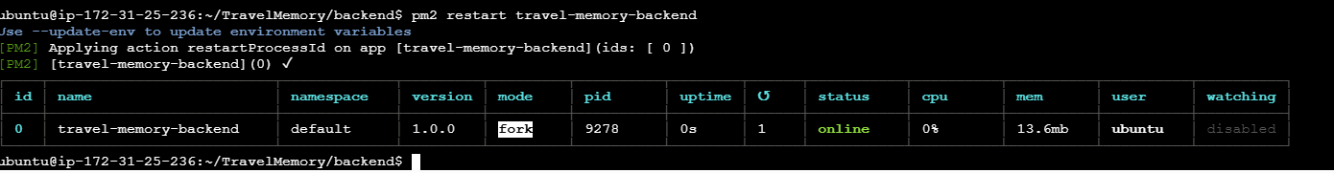

pm2 stop travel-memory-backend
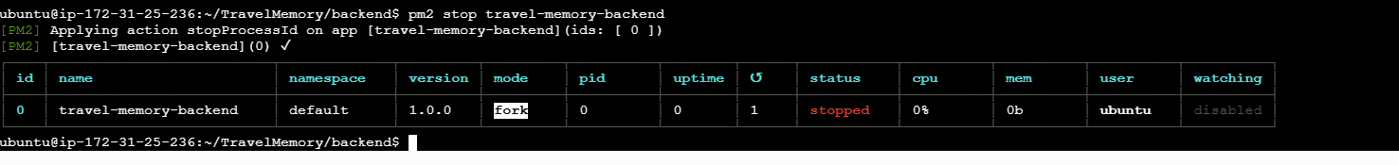
pm2 delete travel-memory-backend

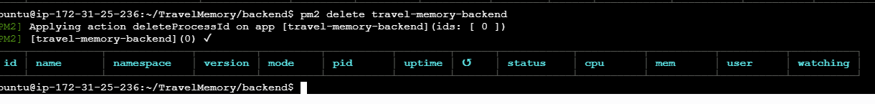

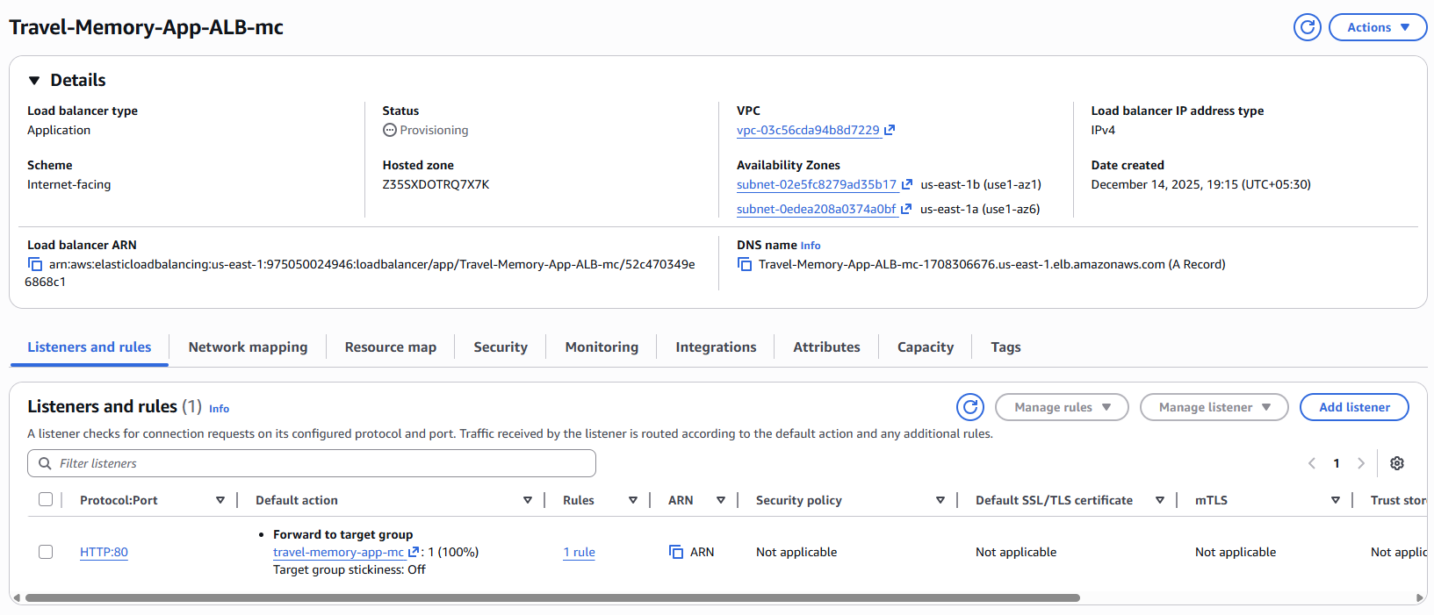

Travel-Memory-App-ALB-mc-1708306676.us-east-1.elb.amazonaws.com

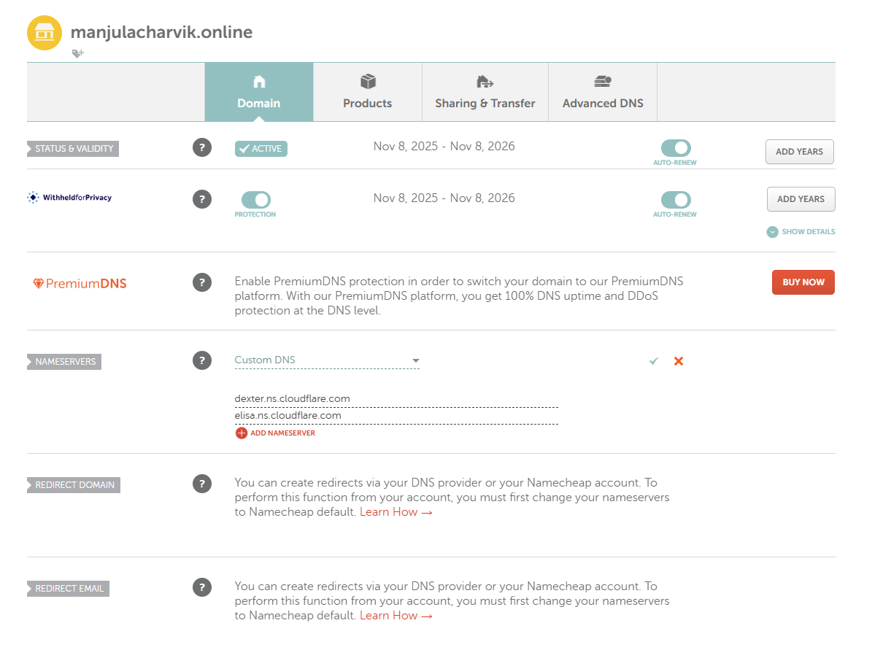

Install certificate :
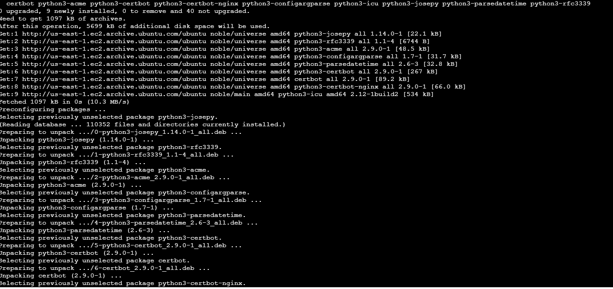

http://manjulacharvik.online
